# **Online Chat Application**

## **Overview**

This is a simple text-based online chat application using Java socket programming. It allows multiple clients to connect to a server, send messages, and receive messages from other users in real-time.

## **How to Run**

### **Server**

1. Compile: javac ChatServer.java
2. Run: java ChatServer
3. The server listens on port 12345.

### **Client**

1. Compile: javac ChatClient.java
2. Run: java ChatClient
3. Connects to the server at 127.0.0.1:12345.

You can open multiple terminal windows and run multiple instances of ChatClient to simulate different users.

## **Features**

* Each client is assigned a unique ID (e.g., User1, User2).
* Broadcasts messages to all connected clients.
* Text-based interface using command line.
* Server handles multiple clients concurrently using threads.

## **Example Interface**

**Screenshot of User Interface:**

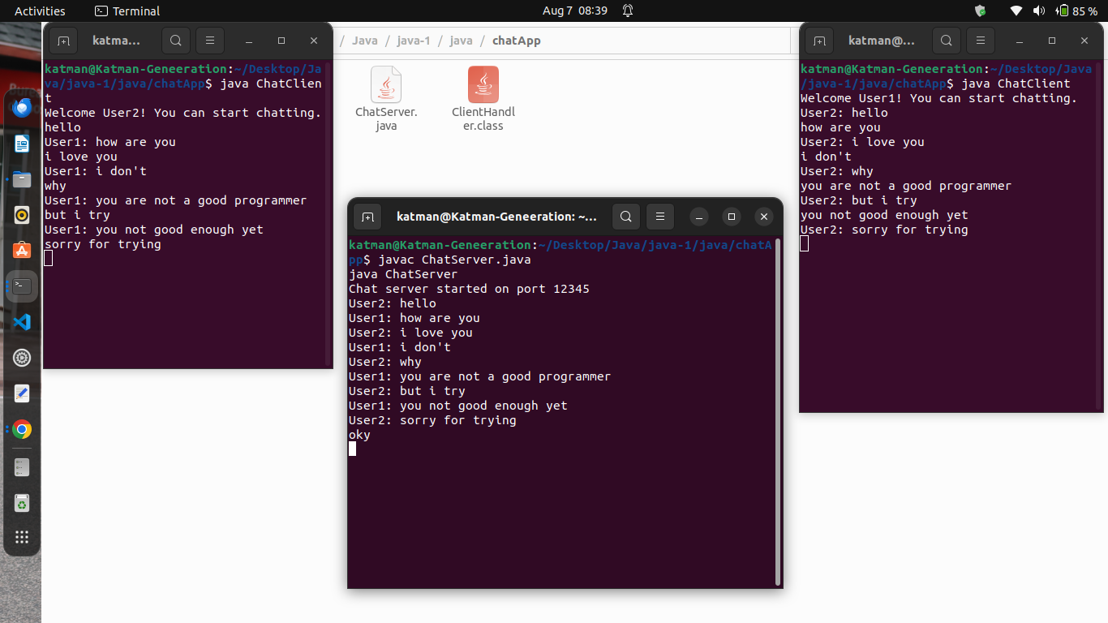

* Server Terminal: